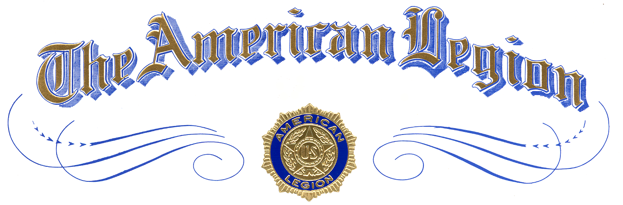

Certificate of Distinction

Recipient
of
School Name

is awarded this certificate of Appreciation
of and Recognition for Active Participation
in

The American Legion
National High School Oratorical Contest

Presented by
Presenter Name
at Location
Month Day, Year

Attest:

